**REGRESSION ANALYSIS**

**Assignment Number 8**

Register Number: 1740256

**Date:** 18/09/2017

--------------------------------------------------------------------------------------------

**Question 1**

**Aim** - A company provided the following information concerning the number of monthly service calls provided and the total cost incurred for its pest control operations during 2016. Find the linear regression equation and estimate the cost of providing 1140 service calls for January 2017.

**Procedure** –

1. Open a new MS Excel Sheet with data provided in the question.
2. Select on data and click the Data Analysis tool pack Button.
3. Click on Regression and choose the independent & dependent variable (X & Y).
4. Choose ‘New Worksheet Ply’ and click on OK.
5. Therefore, the required summary will be created.
6. The regression eqn is calculated by –

* Y= x * x-variable coefficients + y-intercept coefficients.

1. Enter the value of X.

Service variable is X therefore X is 1140.

Y=19.08x + 13.720 = (1140*19.08)+13720 = 35,471.2

**Conclusion** –

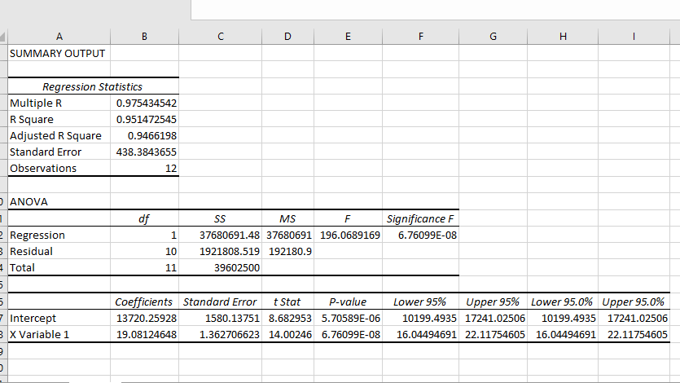

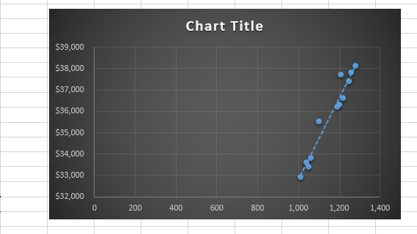

**Conclusion –**

The estimated cost of providing 1140 service calls for January 2017 is Rs. 35,471.2

--------------------------------------------------------------------------------------------

**Question 2**

**Aim** - A fire insurance company wants to relate the amount of fire damage (y) in major residential fires to the distance between the residence and the nearest fire station (x). The study is to be conducted in a large suburb of a major city, a sample of 15 recent fires in this suburb is selected.

**Procedure** –

1. Open a new MS Excel Sheet with data provided in the question.
2. Select on data and click the Data Analysis tool pack Button
3. Click on Regression and choose the independent & dependent variable (X & Y)
4. Choose ‘New Worksheet Ply’ and click on OK
5. Therefore, the required summary will be created
6. The regression eqn is calculated by –

* Y= x * x-variable coefficients + y-intercept coefficients

1. Enter the value of X.

**Calculations** –

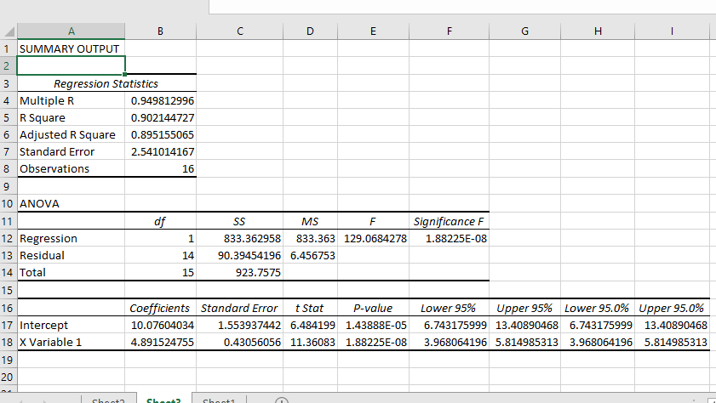

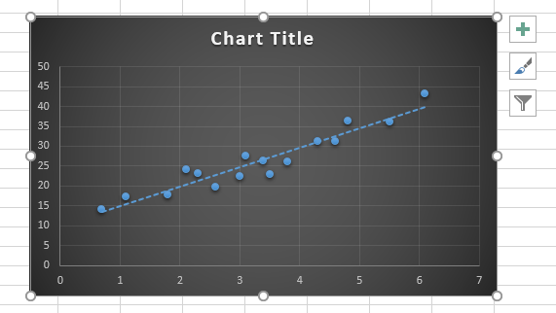

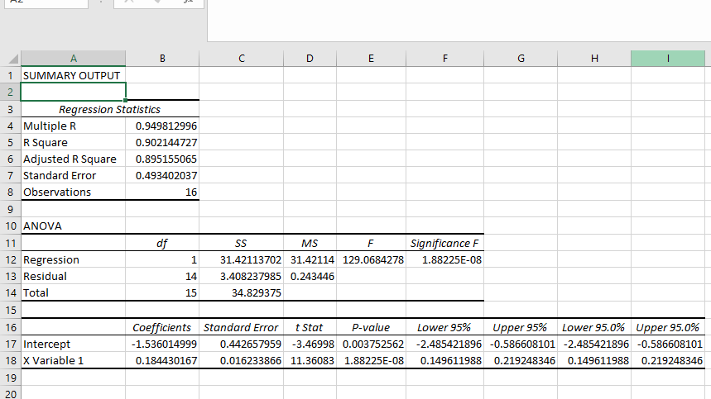

**Conclusion –**

The regression equation for the amount of fire damage (y) in major residential fires on the distance between the residence and the nearest fire station (x) i.e Y ON X is

Y = 4.89X + 10.07

The regression equation for the distance between the residence and the nearest fire station (x) on the amount of fire damage (y) in major residential fires on i.e X ON Y is

X = 0.1844Y + (-1.5360)

= 0.1844Y - 1.5360

---------------------------------------------------------------------------------------------------------------------------------

THE END

--------------------------------------------------------------------------------------------